**INNOVATIVE TECHNOLOGY FOR ARTIFICIAL LIFT PRODUCTIVITY**

**Wellpad Optimization System –WOS**

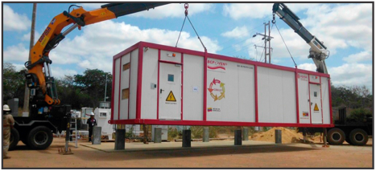

**Wellpad Optimization System –WOS Onshore**

**•** Custom-engineered walk-in metal enclosure.

**•** Well control system (SCP/VSD).

**•** Cluster Control System (CCS).

**•** Emergency Shutdown System (ESS).

**•** Access Control System (ACS).

**•** Clean Agent System (CAS).

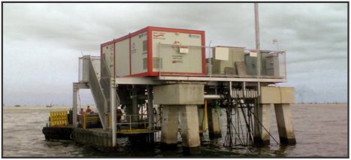

**Wellpad Optimization System –WOS Offshore**

**•** Power quality equipment.

**•** Internal Air-conditioning system.

**•** Power Distribution Center (PDC).

**•** Auxiliary Services Center (ASC).

**•** Regulated Power System (UPS 240 / 120V).

**•** Electrical Surge Protection system.

**CILA 2S Intelligent Controller for Artificial Lift Systems**

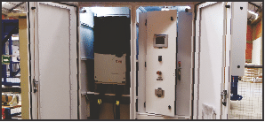

**CILA 2S Intelligent Controller for Artificial Lift Systems**

**•** Integral solution design with different VSD Technologies to control, protect, supervise and optimize different artificial lift methods like PCPs, Rod Pumps, ESP and multiphase pumps.

**•** Knowledge enhancement in artificial lift systems.

**•** Best control and power system technology.

**•** Low harmonics solutions.

**•** Overall system integrity (Surface & downhole).

**PCP Drive-head**

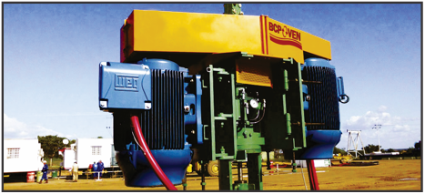

**PCP Drive-head**

**•** Robust and compact design hollow shaft type – standard belt sheave system for PCP applications.

**•** Special Drive-head for gear motor.

**•** Break system features hydraulic equipment with an Oil-gauge.

**•** Self-lubricating seal stuffing box type.

**Surface PCP**

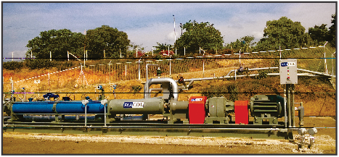

**Multiphase pumping system**

**•** Flow rates up to 50.000 BPD.

**•** Pressures up to 1.000 PSI.

**•** Pumping of oil, gas and water mixtures with solids.

**•** Low and medium voltage.

**Progressive Cavity Pumps (PCP)**

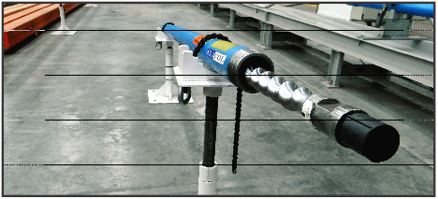

**Multiphase pumping system**

**•** PCP Pumps for different flow rates: From 8 BPD up to 6100 BPD.

**•** PCP Pumps for different diameters: 2-3/8” to 6-5/8” inches.

**•** Use of different types of elastomers, according to technical evaluation.

**SCADA Optimization**

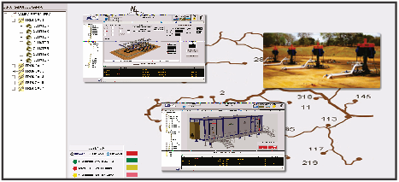

**SCADA**

**•** Access to well conditions and detailed production data.

**•** Display of well operating variables.

**•** Remotely operated wells.

**•** Well performance test and Build-up from control center.

**•** Visual display of the status of each well in the field.

**Test bench facilities**

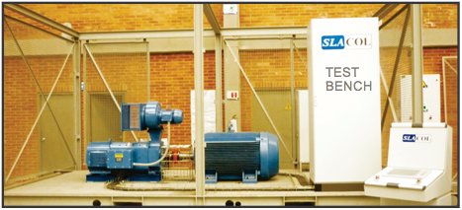

**Test Bench**

**•** Test bench facilities for testing surface equipment: Electric motors and VSD up to 400 amps.

**•** Test bench facilities for PCP in Brazil, Colombia and Venezuela.

**•** Test bench for downhole sensor.

**PCP & ESP Downhole Sensor (DHS)**

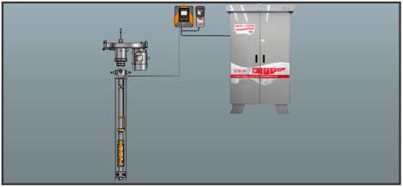

**PCP & ESP Downhole Sensor (DHS)**

**•** Downhole sensor with digital technology.

**•** Intake and discharger temperature: 0 C°– 150 °C.

**•** Intake and discharger pressure: 0 – 5,800 PSI.

**•** Vibration measurement range: 0 – 50 g.

**•** Carrier for pipe: 2 – 7/8 to 5 – ½ inches.

**•** Round or flat communication cable.

**•** Cable clamp protector.

**PCP & ESP System application software**

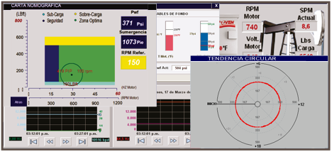

**PCP & ESP System application software**

**•** Nomographic chart for PCP, circular chart for ESP and dynagraph chart for beam pump.

**•** High performance optimization for artificial lift oil production.

**•** Intelligent torque control.

**•** Backspin control.

**•** Staggered start.

BCP-GROUP

800 Town & Country Blvd

City Center ONE – Level 3

Houston, TX 77024

www.bcpgrp.com