**CILA 2S INTELLIGENT CONTROLLER FOR ARTIFICIAL LIFT SYSTEM**

**CILA 2S Intelligent Controller for Artificial Lift System**

The CILA2S is a modular intelligent controller for Artificial Lift Methods (PCP, ESP, SRP) and multiphase system. The CILA2S analyzes, control and optimizes the oil well behavior using power electronics and Added Value Applications & Solutions (AVAS).

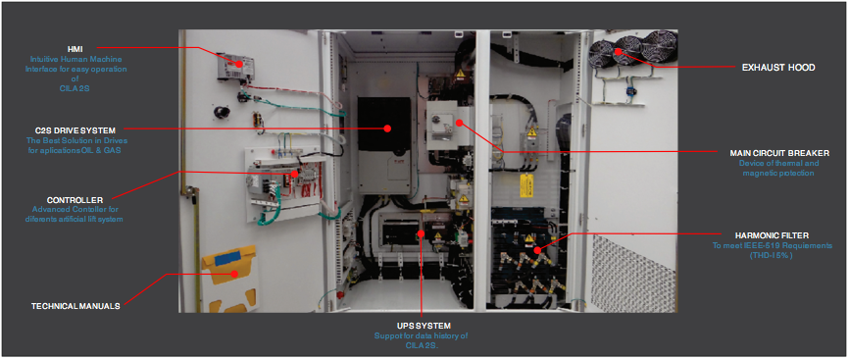

**(CILA2S TYPES)**

TYPE-B TYPE-C TYPE-D TYPE-E

The CILA 2S has the capacity to operate with different brand & technology of induction or permanent magnet motors, focused on oil well applications (Downhole and Surface pumps).

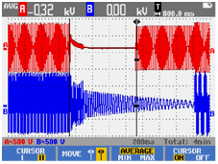

Energy Control (For power sags or disappears)

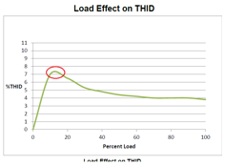 Level of harmonics according

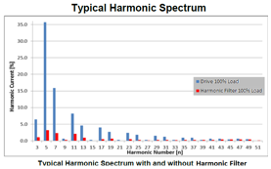

IEEE-519 at low loads

The CILA2S gathers and data processing coming from oil field sensors to maximize the quality of remote response to oil operators and take actions just in time on the oil wells.

* HEAT EXCHANGER = Designed to efficiently transfer heat from one point to another.
* FILTER CHAMBER
* JUNCTION BOX = Connections Field Instrumentation and Power Supply.
* FRONT ACCESS PANEL
* ELECTRICAL COMPONENT CHAMBER

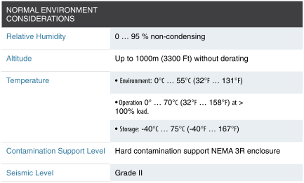

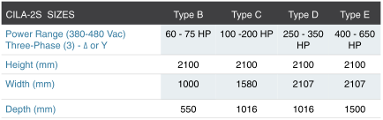

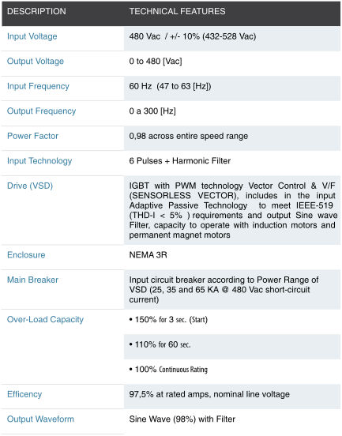

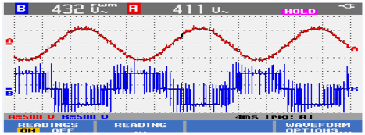

Output sine wave CILA 2S for the Motor